A485-AM,N-NW-Nuu-Chah-Nulth [Nootka]–Beaver Mask-Miniature**-Late 20th century**

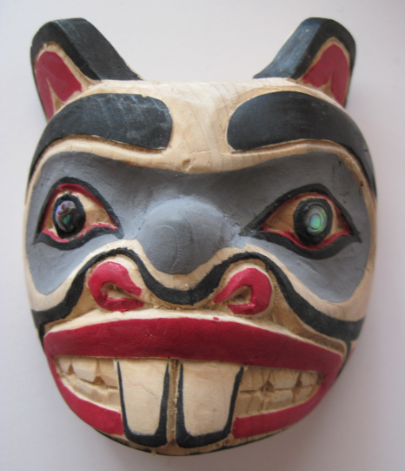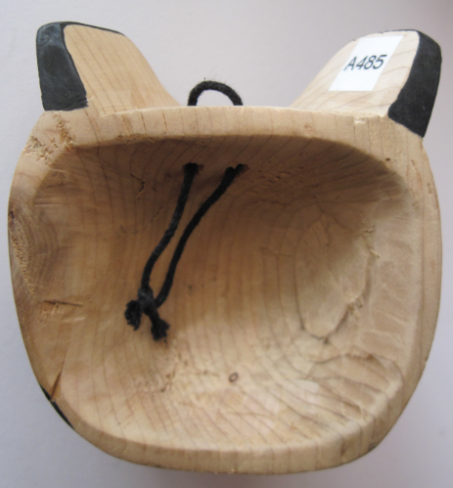

Figs. 1-2. Nuu-Chah-Nulth [Nootka]–Beaver Mask-Miniature**-Late 20th century**

**Case no.: 8**

**Accession Number: A485**

**Formal Label:** Nuu-Chah-Nulth [Nootka]–Beaver Mask-Miniature**-Late 20th century**

**Display Description:**

This is a miniature mask designed by a contemporary Nootka artist to resonate with the late 18th century architectural competition between Britain and Spain who built their garrisons while the Nuu-Chah-Nulth [Nootka] quietly secured their provisioning port on the west coast of Vancouver Island at the Yuquot, a summer village, while their winter villages lay inland and well-hidden from scheming eyes..

**LC Classification**: E99.K9

**Date or Time Horizon:** Late 20th century

**Geographical Area:** Nootka Sound

**Map, GPS coordinates: 49º41'48.32" N 126º30'52.78" W**

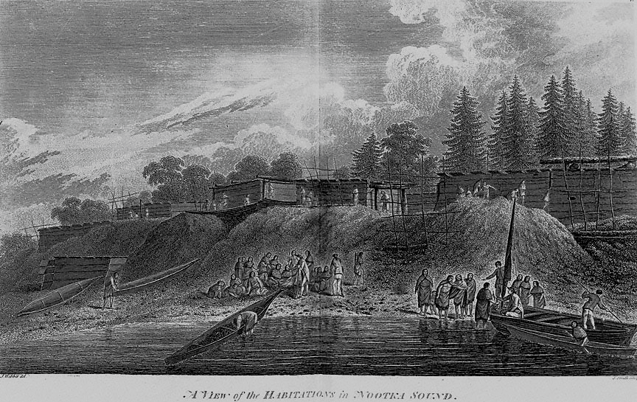

Fig. 3. Captain James Cook’s third Pacific Ocean voyage anchored at Nootka Sound on April 1, 1778, in a protected cove on the west coast of Vancouver Island at the Yuquot summer village of the Nuu-Chah-Nulth [Nootka], Mowachaht branch. *A View of the Habitations in Nootka Sound*, from Cook, 1784.

**Cultural Affiliation:** Nuu-Chah-Nulth [Nootka]

**Media:** Wood; kaolin white, red and blue paint; abalone.

**Dimensions:**

**Weight:**

**Condition: original**

**Provenance:** artist of Spirit Wrestler Gallery, Vancouver.

**Description:**

While this particular mask represents a miniature representation of the beaver as the chief animal architect, its origin from Nootka Sound does resonate with this ancient attempt by two supreme European powers in the 1790’s to assert their claims over the territory by building otherwise insignificant garrisons to protect their much more invisible claims of dominance. The beaver image understates the architectural aspects of the importance of these bases on Nootka Sound and the First Nations architectural opposition pf the Nuu-Chah-Nulth.

Nootka Sound would become an important way-station in the height of the fur trade by 1792 as competing merchant ships from the U. S., Europe and Great Britain re-provisioned their ships in a multi-national marine rendezvous that erupted as territorial ambitions clashed between Spain and Britain in the “Nootka Sound Crisis,” when both claimed dominion over the area by establishing small garrisons at Nootka Sound.

**References:**

Cook, James. 1784. A voyage to the Pacific Ocean: undertaken, by the command of His Majesty, for making discoveries in the Northern hemisphere, to determine the position and extent of the west side of North America, its distance from Asia, and the practicability of a northern passage to Europe: Performed under the direction of Captains Cook, Clerke, and Gore, in His Majesty's ships the Resolution and Discovery, in the years 1776, 1777, 1778, 1779, and 1780. London: printed by W. and A. Strahan, for G. Nicol ... and T. Cadell ....

Haycox, Stephen. 1997. Enlightenment and Exploration in the North Pacific, 1741-1805. Seattle: University of Washington Press.

Mozino, José Mariano. 1991. Noticias de Nutka: An Account of Nootka Sound in 1792. Seattle: University of Washington Press.